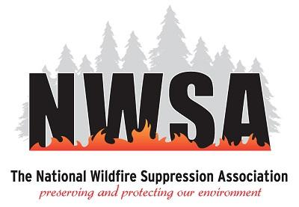

Wildfire Suppression Resource-Specific Pre-Season Meetings
Date: March 12, 2026
Location: Peppermill Resort, Reno, Nevada
__________________________________________________________________________

Agenda – Thursday, March 12, 2026
- 8:00 a.m. – 8:30 a.m. – Welcome and Sign-In – Naples Welcome Center
- 8:30 a.m. – 9:45 a.m. – Water Handling Vendors – Naples 6 & 7

- 10:00 a.m. – 11:30 a.m. – EMS Vendors – Naples 6 & 7

- 11:30 a.m. – 1:00 p.m. – Lunch (On your own)

- 1:00 p.m. – 2:30 p.m. – Base Camp Resource Group – Naples 6 & 7

- 2:30 p.m. – 4:00 p.m. – Miscellaneous Resources Session (Heavy Equipment, Fallers, Weed Washing, etc.) – Naples 6 & 7

